We are having a quiz on the microscope on ______________________________.
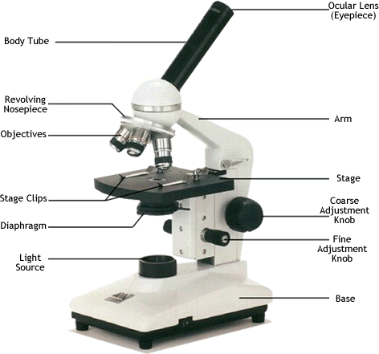
Study the names of the parts of the microscope. You will be required to label a diagram.

Study your microscope packet. You will need to know how to calculate the power of each lens on the nosepiece.
You will also be required to explain how to focus a slide using high power.

