How do living things get energy?
Chemical energy that is stored in food is changed through chemical reactions in cells into forms needed to carry on all life functions. All the chemical reactions in an organism together are called the ______________________.
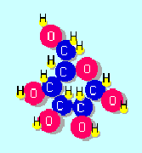
Energy has been stored in this molecule of glucose. The energy can be released using enzymes in your cells.

Read p. 81 in your textbook to understand the role enzymes play in releasing energy. Then circle the correct answers below.

Enzymes are like…
- A can of spaghetti
- A can opener

Enzymes…
- Cause changes, but remain unchanged
- Cause changes, and change form

Enzymes can…
- Can be used over and over again.
- Can only be used once.

Enzymes can…
- Only take molecules apart.
- Take molecules apart or brings molecules together.

