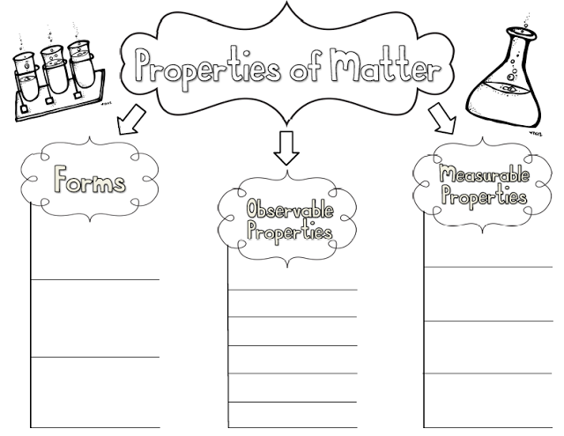
Intensive properties are properties that do not depend on the amount of substance.

Extensive properties are properties that vary depending on the amount of a substance.

Create a table to sort the properties you listed above as intensive or extensive properties.

