Section 2: Sea Floor Spreading
Using _______________ equipment developed during World War I, scientists were able to map the ocean floor.
Method: _________________________________________________________
_________________________________________________________________
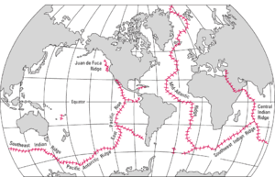
This led to the discovery of a system of mountains and valleys in the middle of the ocean floor.

In the early 1960’s ______________________________ suggested an explanation for the existence of the mid-ocean ridges. His explanation is now known as ___________________________________________________.
Description: ___________________________________________________________________
______________________________________________________________________________
Evidence:
- Age of rock along the mid-ocean ridge: __________________________________________________________________________________________________________________________________________
- Magnetic Reversals:
__________________________________________________________________________________________________________________________________________

