Section 3 DNA Notes
Chromosomes are composed of a chemical called ______________, which stands for deoxyribonucleic acid.
A strand of DNA ___________________ long is coiled around itself so many times that it can fit inside the ___________________________ of a cell!
In 1953, the scientists, _______________________________________ and _______________________________________ made a model of DNA.
The model looks like a ___________________________________________________________.
The sides of the ladder are made of _________________________ and __________________________
molecules. The sugar is known as deoxyribose.
The rungs of the ladder are made of ______________________________________________.
There are four bases:
- _____________________________________
- _____________________________________
- _____________________________________
- _____________________________________
The nitrogen bases always occur in the following pairs:
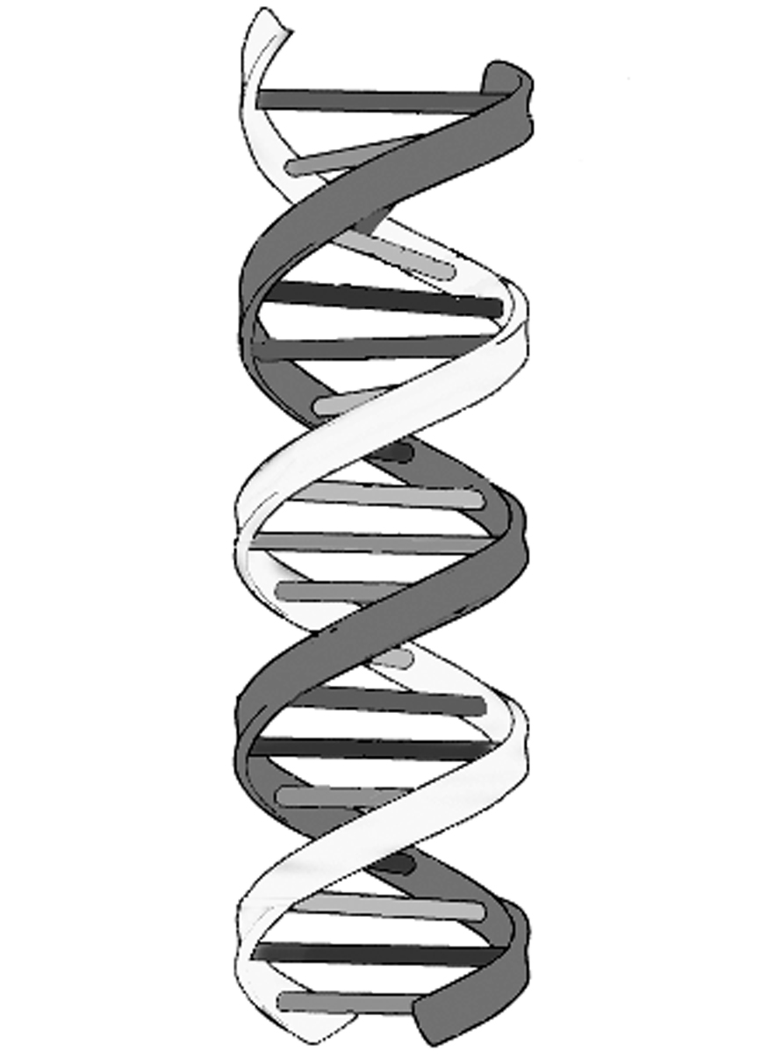
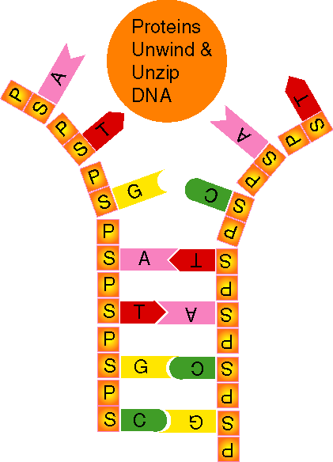
When DNA is preparing to be copied during interphase, the molecule ________________.
Each side of the molecule
Is paired with the appropriate
nitrogen bases.
This results in two

strands of DNA.
The order of the nitrogen bases determines the type of ____________________ that will be built.
Sometimes mistakes, called ________________________, are made during the copying process.
These changes can be _________________________
or
_________________________
for the organism involved.

