States of Matter
You have been given a special pair of glasses that enable you to see the atoms that make up matter. In the first jar is a cube shaped sample of matter in its solid state. The second jar has been heated so that the sample of matter has changed to liquid state. The third jar has been heated even more, and all the liquid matter has changed to a gas. Put on your special glasses and illustrate what you would see in each jar. Add labels to explain how the atoms are moving in each jar.

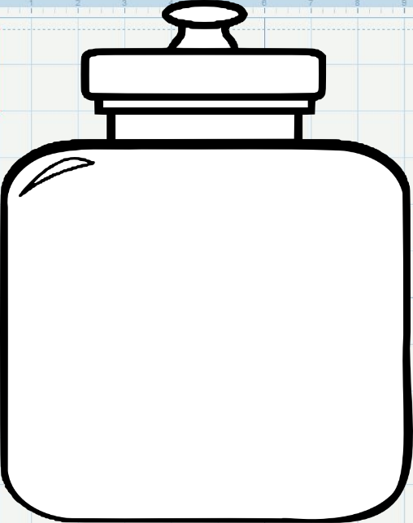

Matter in this jar is solid. Matter is in liquid state. Matter is in the gas state.

