[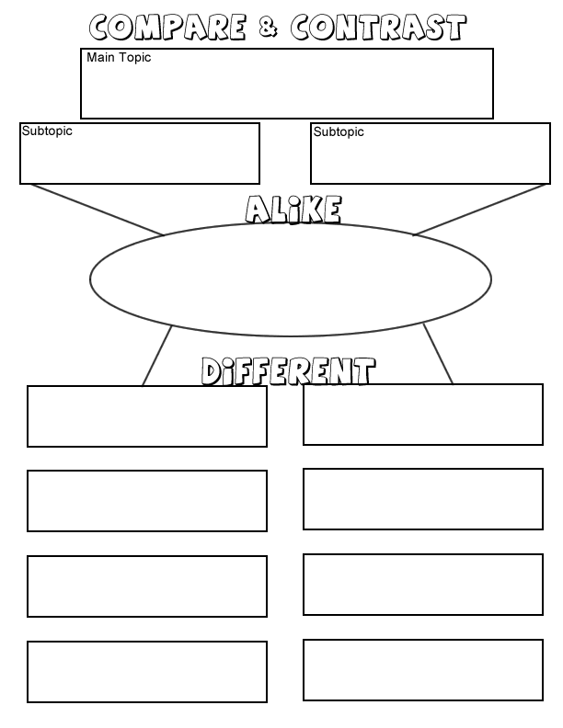](http://www.google.com/url?sa=i&source=images&cd=&cad=rja&docid=udv8LatN1dw6ZM&tbnid=ZLVw092NilpCsM:&ved=0CAgQjRwwAA&url=http://www.biologycorner.com/worksheets/graphic_compare.html&ei=j-N2UtTmAaSayQHTyoDgBg&psig=AFQjCNHNVsKqATsKODwlGXfTCkgEsSdOpQ&ust=1383609615079256)