Forces of Mountain Building

__________________________ _________________________
(action) (action)
_____________________________________ ____________________________________
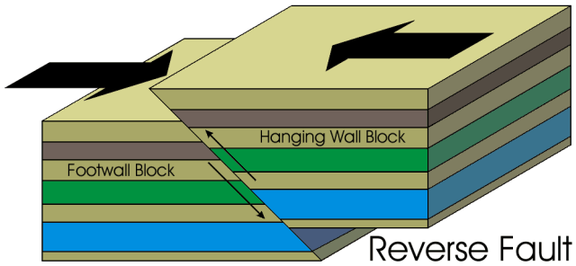
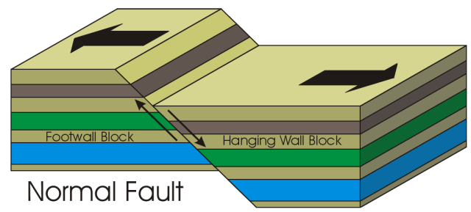
Resulting in a … Resulting in a …

Describe motion at the fault: Describe motion at the fault:
____________________________________ ____________________________________
____________________________________ ____________________________________
____________________________________ ____________________________________
(mountain type) (mountain type)
____________________________________ ____________________________________
Examples: Examples:
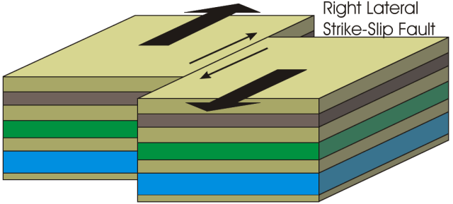
Result from:
____________________________________
(action)
_____________________________________
_____________________________________

