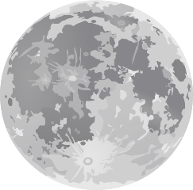
How Tides Work Video Watching Guide
http://science.howstuffworks.com/environmental/earth/geophysics/tide-cause.htm
Use this guide to record important information you will learn while watching this video. The information is presented in the same order as the questions.
Name the 3 factors that cause tides on Earth.
- ________________________________
- ________________________________
- ________________________________
Circle the biggest factor.
What force pulls the Earth’s oceans toward the moon?
_______________________________ force
True or False? The Earth itself is pulled toward the moon. _______________
What kind of tide occurs on the side of Earth facing toward and away from the moon?
____________ tide
What kind of tide occurs on the sides of Earth at right angles to the moon?
____________ tide
What kind of tide is created when the sun, moon and Earth are lined up?
____________ tide
Think…During what phases of the moon would these tides occur?
_______________________ and _________________________
What kind of tide is created when the moon and sun form a right angle with the Earth?
____________ tide
Think…During what phases of the moon would these tides occur?
_______________________ and __________________________

