Name __________________________________
Metamorphic Rock
Metamorphism: meta= _______________ morphos=_________________
Temperature and/or pressure increase
__________________ rock
__________________ rock metamorphic rock
__________________ rock is formed
What causes metamorphism?
- Heat from nearby magma: ___________________________________
- Large pieces of crust collide or
Pressure builds up on buried rock: _____________________________
- Interaction with _____________________________ released during metamorphism of other rock
Composition of Metamorphic Rock
Minerals that only form at certain temperatures and pressures are called
_____________ _________________________.
By examining the minerals a rock contains, we can estimate the _____________________ and ____________________ at which the rock underwent metamorphism.
Example:
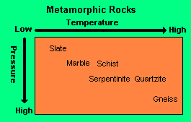

Texture of Metamorphic Rock
There are _______ kinds of textures in metamorphic rock.
- ______________________: minerals are aligned in bands (looks like stripes)
- Example: _________________ to ___________________
- ______________________: minerals are not arranged in bands
- Crystals may __________________ in a process called
recrystallization.
- Example: ___________________ to _____________________

