Mineral Mobile Project
- Gather the required information about your mineral. You can find information on websites or in books.
One helpful website is www.minerals.net
- Make a mobile to display the information Using a hanger and paper provided in class. Fold the paper in half lengthwise. Make a slit in the middle of the fold and place the paper over the hook of the hanger.
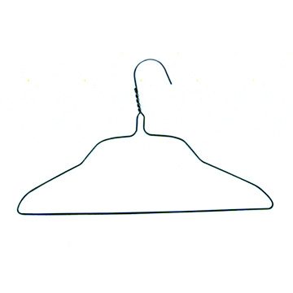
Fold

Tie yarn from the bottom of the hanger to three cards. Secure the paper over the hanger using a glue stick.
- On the front of the paper identify the mineral, its chemical formula, its group (silicate/non-silicate) and include a picture of the mineral.
- On the back of the paper include information about the discovery of the mineral, its special properties (if any), its locality and uses.
- On one side of each card, list a physical property of your mineral.
- Your mobile is a visual display. It will be graded on neatness and organization as well as accuracy of information.
- While it is acceptable to print information by hand, computer generated text typically has a neater appearance.

Date Due: ______________________________________________

