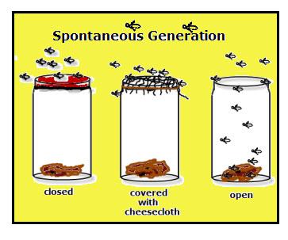
Notes: Section 3, Where Does Life Come From?

Spontaneous generation was an early idea based on observations and inferences that suggested:
____________________________________________________________
____________________________________________________________
The earliest scientific experiments were conducted to test these ideas by scientists such as:
________________________________________________________________________________________________
________________________________________________________________________________________________
The BIG idea of using SCIENTIFIC METHODS to test hypotheses developed from these experiments and contained the following important elements:
Observation/question: _____________________________________________________________________________
________________________________________________________________________________________________
Hypothesis: ______________________________________________________________________________________
Procedure for testing the hypothesis: _________________________________________________________________
________________________________________________________________________________________________
Control group: ______________________________________________________________________________
__________________________________________________________________________________________
Experimental group: __________________________________________________________________________________________
__________________________________________________________________________________________
Collecting and Analyzing data: ________________________________________________________________________
_________________________________________________________________________________________________
Drawing conclusions: ________________________________________________________________________________
__________________________________________________________________________________________________
Because of the experiments of these early scientists, Spontaneous Generation was replaced with the theory of BIOGENESIS, which states that _________________________________________________________________________
__________________________________________________________________________________________________
Scientists continue to hypothesize about the origins of life on Earth.
Oparin’s hypothesis states____________________________________________________________________________

