The Law of Conservation of Matter
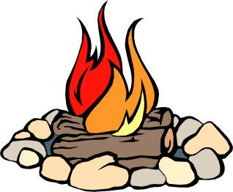
At one time, people thought matter could just appear and disappear.
Observation: ________________________________
__________________________________________
Inference: __________________________________
__________________________________________

Observation: _____________________________________
________________________________________________
Inference: _______________________________________
________________________________________________

According to the Law of Conservation of Matter,
Matter cannot ________________________________________________________________
Matter can ___________________________________________________________________

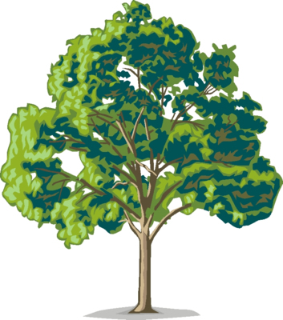

A tree starts as a tiny _____________________________.
Where does all the mass of a tree come from?
A tree changes ____________________________________
Into other forms of matter that help it grow.

