Cut out the words and pictures below. Divide your paper into two columns. Place the Labels quiet eruption/ explosive eruption at the top of each column. Sort the remaining words and pictures and glue them in the correct column.

High Silica low silica quiet eruption

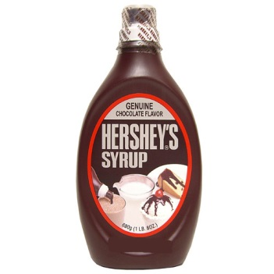
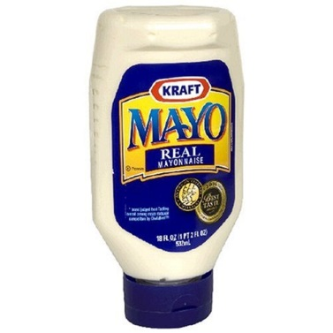
Explosive
eruption

Basaltic granitic
Magma Magma

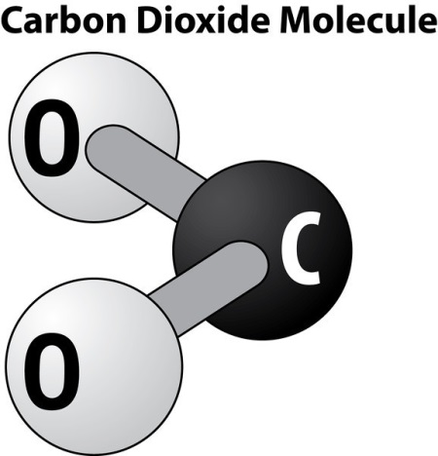
High Low
Viscosity viscosity

